MAT Methods: TOPIC TEST 2-Quadratic Functions,Powers Polynomial Functions and Inverse Functions Course Weighting: 5% Total Mark /63 marks

**Section 1 : No Calculator allowed Marks allocated: 20 Time allowed 20 min**

**Question 1 [1, 2 = 3 Marks]**

1. Given that,  find:

(i) 

(ii) if

**Question 2 [3, 2 = 5 Marks]**

Determine as simply as possible, if they intersect the x-axis and if they do, determine the specific location.

(a) $y=x2+3x-1$

(b) $y=-2x2-x-4$

.

**Question 3 [1, 1 = 2 Marks]**

Write the vertical and horizontal asymptotes of the following equations.

1. $y=\frac{3}{x-6}$.

$y=\frac{1}{4x-3}+2$

## Question 4 [2, 2 = 4 Marks]

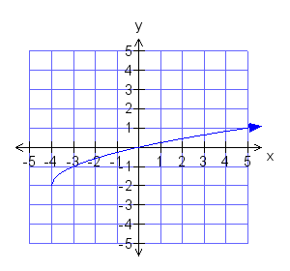The function shown has the equation $f\left(x\right)=\sqrt{x+p}+q$

(a) State the values of *p* and *q*.

(b) State the domain and range of the function.

**Question 5 [2, 2 & 2 = 6 Marks]**

Consider the graph of y = f(x) below.



a) Sketch on the axes provided:

(i) y = f(x + 1) - 3 (ii) y = -2f(x)





b) Find the *x* intercepts for y = f () __________________________

MAT Methods: TOPIC TEST 2-Quadratic Functions,Powers Polynomial Functions and Inverse Functions

**Section 2: Calculator allowed Marks allocated: 43 Time allowed 40 min**

Question 6 [2, 2,1,2 & 2 = 11 Marks]

The three functions below have been graphed over the domain .

|  |  |  |
| --- | --- | --- |
|  |  |  |

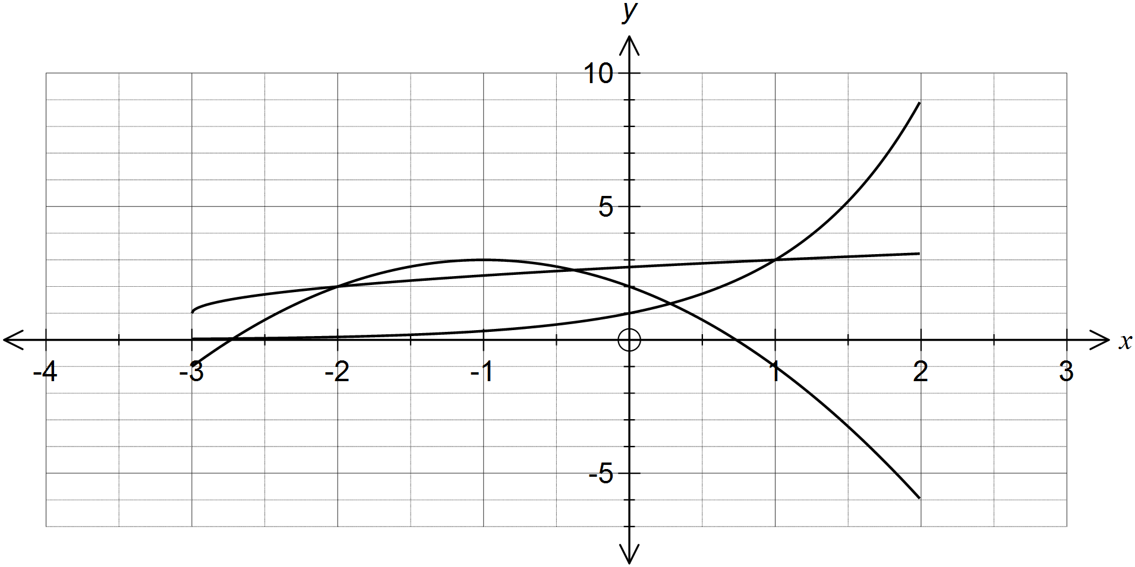

(a) Over the given domain, state the range of

(i) 

(ii) 

(b) Which function has symmetry when graphed over its natural domain?

(c) State which function has an asymptote and write down it's equation.

(d) Use the graph to estimate all solutions to .

**Question 7 [2,2 = 4 marks]**

1. Solve $y=2x2-x-3=0$
2. Solve $y=\left(x-3\right)2=4$

**Question 8.** **[2,2,1,2 = 7 marks]**

A crane is used to lift and assemble the concrete panels used to construct an office building. On the sixth day of construction there are a total of 24 panels in place. Let P represent the number of panels and let d represent the number of days the building has been in construction.

1. Explain why this is an example of direct rather than inverse, proportion.
2. Determine k, the constant of proportionality.
3. Hence or otherwise establish a defining rule for this situation, using the variables P, for the number of panels, and, d for the number of days of construction.
4. There are a total of 44 panels used to construct this building. How many days will it take to complete the assembly of the building?

**Question 9 [1,5,1,1,1 2 = 11 Marks]**

Joshua’s Acme Bank shares were released on March 1, 1991. The value *v* of a share in dollars was given by:

$$v\left(x\right)=0.1x\left(x-5\right)\left(x-6\right)+2.5, x≥0$$

Where $x$ represents the number of months since March 1,1991

1. What was the value of a share on March 1, 1991?
2. Sketch the graph of the following cubic showing x and y intercepts and maximum and minimum points. $y=v\left(x\right)-2.5$

For the function: $$v\left(x\right)=0.1x\left(x-5\right)\left(x-6\right)+2.5, x≥0$$

1. How long was the value of a share below its initial value?
2. Did the value of the shares ever reach $5.50 in the first 6 months? Explain.
3. The value (*V*) of the shares is to be expressed in cents. Write an equation for $V\left(x\right)$.
4. What would the $v\left(x\right)$ and $V\left(x\right)$ graphs have in common? How would they be different?

**Question 10 [1,2,3 = 6 Marks]**

1. Determine the radius and the centre point of the following equations.
$\left(x-2\right)2+\left(y+5 \right)2=4$

$x2+8x-2y-8+ y2=0$

2. State the equation of the circle with a radius of 2 units and a center at the midpoint between the two centers of A and B.

**Question 11 [2,1,2, 1 = 6 Marks]**

Nick’s toy rocket is fired into the air from ground level. The equation of the flight path was $h=-2t2+20t$ where h is the vertical height is metres and t is the time since launch in seconds. Unfortunately the toy rocket crashed into the top of a streetlight, on the way down and was smashed into pieces.

1. At what time does the rocket reach its maximum height?
2. What is the maximum height?
3. When was the rocket 25 metres in the air?
4. The rocket crashed into the goal post after 9.5 seconds of flight. How tall is the streetlight?